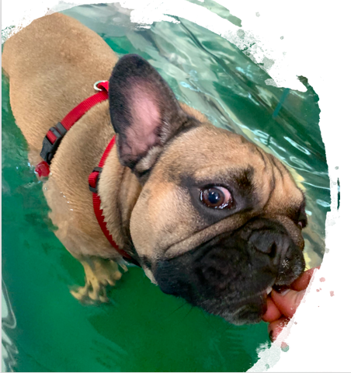
Registration Canine Neurorehabilitation and NeuroFacilitation Weekend, October 16-18, 2020
Lubbeek

Name & Surname:

Address:

Telephone:
Email:

VAT number:

Education:
- Physio
- Vet

Where did you complete a certification in Animal Physio?

Can you bring a demo dog?
Specifications of the dog?

Please send this form to
sara.coeckelberghs@gmail.com
martine.leijssen@gmail.com

